Name:
Binary – Denary – Hexadecimal

Hexadecimal is the base 16 number system. How did this come about? A byte has 8 bits and can be split into two nibbles (4 bits), the column headings for a 4-bit number add up to 15, we can represent the range of numbers 0 – 15 (ie 16 numbers: 0, 1,2, 3, 4, 5, 6, 7, 8, 9, 10, 11, 12, 13, 14, )15
Add together
= 15

8 | 4 | 2 | 1
1 | 1 | 1 | 1

Converting binary to hexadecimal:

11110011 into hex:

Split the 8 bits into two nibbles: 1111 0011
8 | 4 | 2 | 1
0 | 0 | 1 | 1

8 | 4 | 2 | 1
1 | 1 | 1 | 1

Put into the column headings:

Add the column headings together: 15 3

In hexadecimal this becomes: 3F

Converting denary to hexadecimal:

45 denary into hex:

Divide the number by 16 repeatedly and note the remainder:
45 | /16 | = 2 | Remainder | 13 = D
2 | /16 | = 0 | Remainder | 2

The number is placed before the letter so 45 is converted to 2D

Converting hexadecimal into binary:

128 | 64 | 32 | 16 | 8 | 4 | 2 | 1
0 | 0 | 0 | 0 | 0 | 0 | 1 | 1

3B hex into binary:

3 in binary = 0011

128 | 64 | 32 | 16 | 8 | 4 | 2 | 1
0 | 0 | 0 | 0 | 1 | 0 | 1 | 1

B = 11 = 1011

Put the two nibbles together to get a byte and this gives 111011
NB: you do not need to include any 0s at the beginning so 00111011 is the same as 111011
Hexadecimal:

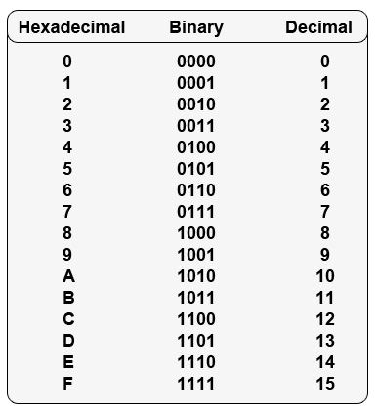

Homework:

- Convert 28, 72, 131, 235 and 255 from denary to binary

- Convert 1011, 11011, 10001010 and 11001000 to denary

- How many kilobytes are there in a gigabyte?

- Add the following numbers in binary and show your working:

  - 1010 + 101
  - 10001 + 11001
  - 111001 + 100011

- Convert the following binary numbers into hexadecimal:
- 10010011 b) 10101000 c) 111011

- Convert the following hexadecimal numbers into binary AND denary:
- 1A b) 35 c) BC

