### Binary and Decimal: Designing sprites extension worksheet

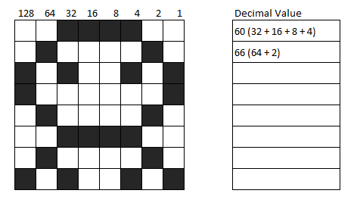

**Task One:** For the sprite shown work out the decimal value of each row. The first two have been done for you.

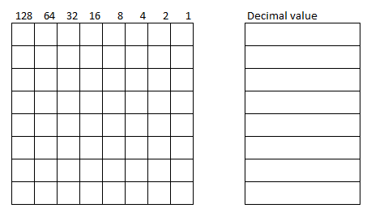

**Task Two:** Use the grid to draw your own alien sprite for a space invaders game. Then work out the decimal value of each row.

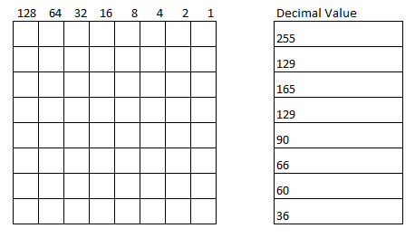

**Task Three:** Convert each decimal value to binary using <http://www.binaryhexconverter.com/decimal-to-binary-converter> then use the binary code to complete the grid and draw the sprite.