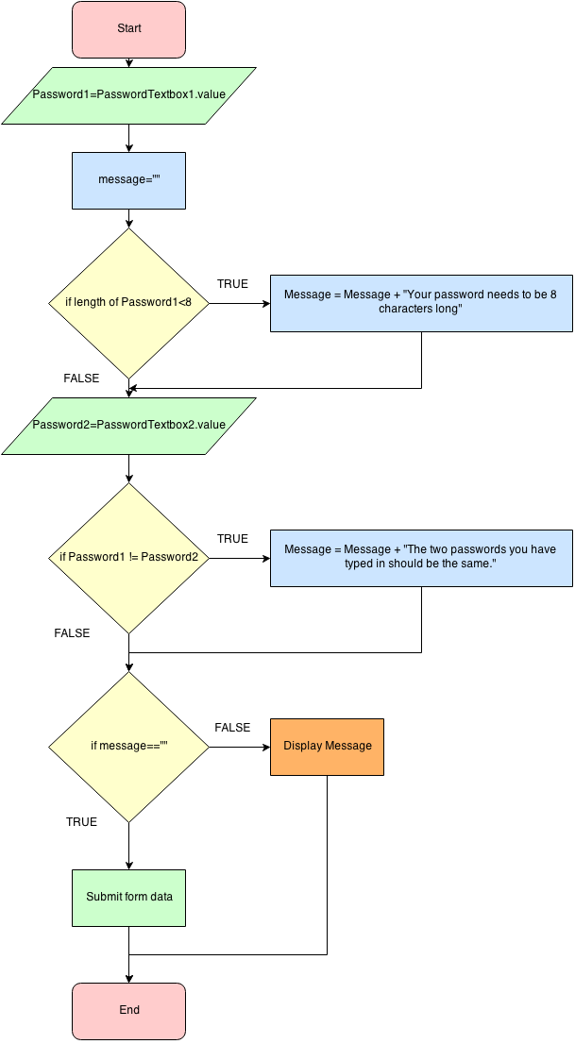
Look at the Algorithm on the left and create a Pseudo code version on the right

INPUT – indicates a user will be inputting something, OUTPUT – indicates that an output will appear on the screen
WHILE – a loop (iteration that has a condition at the beginning)​, FOR – a counting loop (iteration)
REPEAT – UNTIL – a loop (iteration) that has a condition at the end, IF – THEN – ELSE

