Mesh Topology  Devices are connected with many redundant interconnections between network nodes. In a true mesh topology every node has a connection to every other node in the network. | 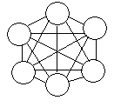
Star Topology  All devices are connected to a central hub. Nodes communicate across the network by passing data through the hub. | 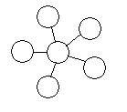
Bus Topology  All devices are connected to a central cable, called the bus or backbone. | 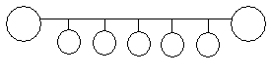
Ring Topology  All devices are connected to one another in the shape of a closed loop, so that each device is connected directly to two other devices, one on either side of it. | 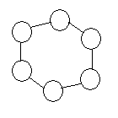
Tree Topology  A hybrid topology. Groups of star-configured networks are connected to a linear bus backbone. | 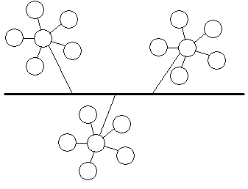

Technology | Speed | Wireless | Range | Support | Cost
Ethernet 10/100 | 100Mbs | N | A | A | A
802.11b | 11Mbps | Y | B | A | B
802.11a | 52/72 Mbps | Y | C | B | C
PhoneLine 2.0 | 10Mbps | N | A | B | B
Gigabit Ethernet | 1000Mbps | N | A | D | D
802.11g | 22/54Mbps | Y | C | NA | NA
Firewire | 400Mbps | N | D | C | A
Bluetooth | 1.5Mbps | Y | D | C | C
HomeRF 2.0 | 10Mbps | Y | B | C | C
PowerLine | 14Mbps | N | A | C | C

