The Scratch Phone Challenge.

Challenge Create a working module for the new ‘Scratch Phone’. You are to put together a working simulation for the next phone to hit the market.
What you need to consider:
- The overall design of the phone
- The style of interface you will be using (e.g. Android/iOS/Blackberry)
- The style of the buttons
- What apps will be included as standard
- How to make those apps work
You may work in pairs for this but you should remember to split the task between you so that each person creates a different app; then put them together near the end.
A sample is shown here to get you started
The overall look  Think about getting images of the latest phones and then editing them to create your ‘concept’ version. | The sprites  Remember – each element that needs to be pressed/ moved etc. will need to have a sprite – some may have other costumes as well  Buttons  Think about how you can make the app buttons have a similar look.  E.g. Music app  How will your app work when it is pressed? This one makes use of the sound function to play a music track  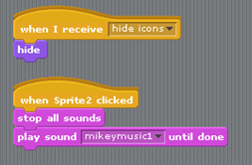  Some sample code is shown below:

