Secondary Storage Technologies CLICK HERE FOR NOTES

Storage Device | Features | Capacity (Size of Memory) | Speed | Portable | Durability  (How long it lasts) | Reliability

External Hard Disk
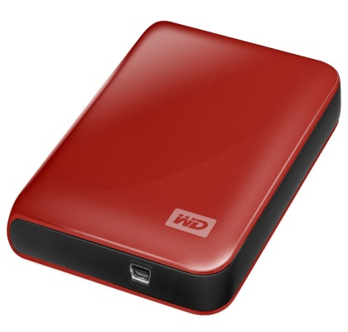

Magnetic tape backup

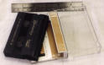
CD-ROM
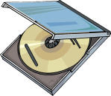

CD-RW

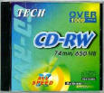
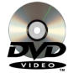
DVD

Flash Memory Stick
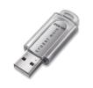

SD Card

Cloud stotage

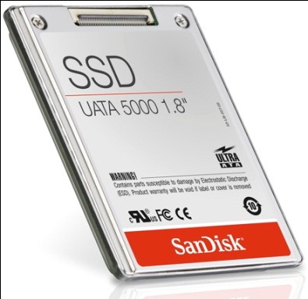

ssd

Selecting the right device

Here is a list of some computer applications. By each application write down the name of the storage device which would be most suitable for the application.
A multimedia "book".
Storing a program to be used in an embedded system in a video recorder.
Taking backups of a hard disk drive.
Copying files from a computer at home to a computer at school.
An employee wants to access work from anywhere and via any computing device
Make up your own
Make up your own
Make up your own
Make up your own

Maybe challenge your friend?

Starter

Complete the blanks using words from the list.
You should use each word only once.

backup tape erased read
backing media WORM compact
hard read/write cartridges serial
- _________ storage is used to store programs and data when they are not being used or when a computer is switched off.
- Magnetic __________, floppy disks, and __________ disks are all types of backing storage __________.
- Magnetic tape comes in reels or ______________. It is used to make _____________ copies of programs and data. Magnetic tapes allow only _____________ access to data.
- CD-ROM stands for _____________ disk __________ only memory. A CD-ROM can store approximately four hundred times more data than an ordinary 3½ inch floppy disk. Data stored on a CD-ROM cannot be changed or _____________.
_____________ disks are a special type of compact disk that are supplied blank and can have data written or ‘burned’ onto them using special ________________ CD drives.

Reasons for Secondary Storage

What reasons can you think of for needing Secondary Storage technology?

