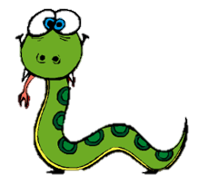
Python – Using Variables

Remember, save each program with the task number. Name: _____________

Task 14
Copy the following program into Python and run it to see what it does.
import turtle
sides = int(input("How many sides would you like? "))
for i in range(sides):
turtle.pencolor("Red")
turtle.forward (50)
turtle.right(30)

- Describe what the program does:

- Explain what you think lines 2 and 3 of the program do:

Task 15
Change the program so that it now also asks you what pen colour you would like. (You will not need to use the int command, as you are not converting the input into an integer).
Explain the changes you made below:

Task 16

Next you’re going to think about changing the program so that it will always draw a complete shape. Complete the table below:

Number of sides | Angle turtle needs to turn
3
4
5
6
8

How do you work out the angle if you know the number of sides?

Complete the equation below (which should calculate angle in terms of sides):

angle =

Task 17

Now change your program (or the original one in Task 14) so that a complete shape is always drawn, however many sides the user asks for. Describe and explain any changes you made below:

Task 18 Challenges

- Write a program to create the following shape – it’s possible to do in only a few lines of code.
b) Get the program to ask the user what shape to draw – if they enter square, it should draw a square etc. (You will need to find out how to use the if command )

