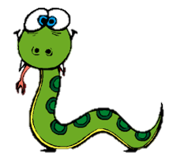
Python – Repeating Instructions

Remember, save each program with the task number.

Task 7 Repeating instructions
Writing out the same instructions many times is not very efficient. Use the program below to write instruction in the form of a loop. The code on lines 3 and 4 is indented – this is important – it tells the program that these lines are to be repeated inside the loop.
import turtle
for i in range(4):
turtle.forward(100)
turtle.right(90)

Task 8
Have a look at the program below and try to work out what it will do. Think about:
- When the turtle will be drawing and when it won’t
- Which lines of code will be repeated and which won’t
import turtle
turtle.penup()
turtle.backward(300)
turtle.pendown()
for i in range(4):
turtle.forward(100)
turtle.right(90)
turtle.penup()
turtle.forward(150)
turtle.pendown()
for i in range(4):
turtle.forward(100)
turtle.right(90)

Now enter the program and run it to see if you were correct.

Write programs to draw the following patterns
Task 9

Task 10

(Hint: when drawing these 5 sides, the turle turns through 360º twice)

Task 11

Extra credit for using less than 15 lines of code!

Task 12 Task 13

